VPrivCal Expert Review
  - Direct-use screening workbook for VPrivCal-Q10 and VPrivCal-Probe
Short workshop version for professional researchers
Decision / research question
Are the three-option trigger questions, expert-verified exposure labels, Probe workflow, and held-out evaluation ready for cognitive testing?

Method at a glance
Element | Current design
VPrivCal-Q10 | Ten direct policy questions; Q1-Q6 share one three-option trigger scale.
VPrivCal-Probe | Three egocentric scenes spanning private, public, and semi-public contexts. Participants point first, then review every predefined category present in each scene.
Calibration target | Pilot target: approximately 5-7 minutes total for Q10 plus the revised category-complete Probe; timing must be confirmed empirically.
Effectiveness test | Generic versus Q10-only versus full VPrivCal on the same locked expert-verified held-out cues.
Expert output | Keep/revise/remove decisions for the questions, exposure rule, Probe, stimuli, and evaluation.

Version 7 | July 2026 | Three-option trigger edition

1. Reviewer instructions
Complete ratings independently before discussion. Judge the current design as written. Proposed fixes belong in the comment fields and should not inflate the current rating.
Rating | Meaning
1 | Major problem / not ready
2 | Substantial revision needed
3 | Acceptable with minor revision
4 | Strong / ready for cognitive testing

2. Method workflow
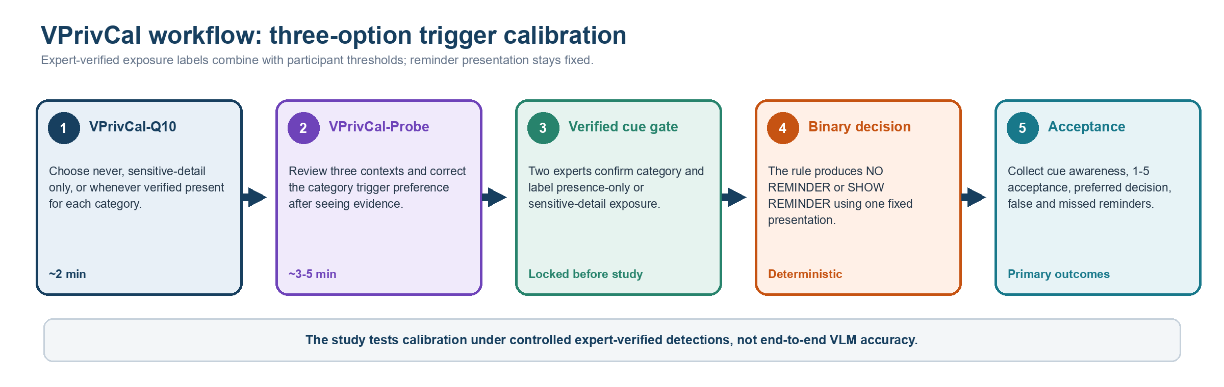
Review question | Rating / comment
Does the workflow make clear that Q10 and Probe are two components of one method? | 1 2 3 4 Comment: ______________________________
Is the revised 5-7 minute pilot target credible without forcing rushed responses? | 1 2 3 4 Comment: ______________________________
Is it clear that effectiveness is measured on held-out video cases, not during the probe? | 1 2 3 4 Comment: ______________________________

3. VPrivCal-Q10 candidate questions
Shared three-option trigger scale for Q1-Q6
1 Do not show reminders for this category | 2 Show reminders only when identifying or sensitive details are exposed | 3 Show reminders whenever this verified category is present

Item | Category / policy dimension | Relevance | Clarity | Actionability | Predictive value | Decision
Q1 | Biometric data | 1 2 3 4 | 1 2 3 4 | 1 2 3 4 | 1 2 3 4 | Keep / Revise / Remove
Q2 | Children images | 1 2 3 4 | 1 2 3 4 | 1 2 3 4 | 1 2 3 4 | Keep / Revise / Remove
Q3 | Personally identifiable information (PII) | 1 2 3 4 | 1 2 3 4 | 1 2 3 4 | 1 2 3 4 | Keep / Revise / Remove
Q4 | Legal sensitivity information | 1 2 3 4 | 1 2 3 4 | 1 2 3 4 | 1 2 3 4 | Keep / Revise / Remove
Q5 | Personal life | 1 2 3 4 | 1 2 3 4 | 1 2 3 4 | 1 2 3 4 | Keep / Revise / Remove
Q6 | Background individuals | 1 2 3 4 | 1 2 3 4 | 1 2 3 4 | 1 2 3 4 | Keep / Revise / Remove
Q7 | Inferred privacy risks | 1 2 3 4 | 1 2 3 4 | 1 2 3 4 | 1 2 3 4 | Keep / Revise / Remove
Q8 | Other verified privacy categories | 1 2 3 4 | 1 2 3 4 | 1 2 3 4 | 1 2 3 4 | Keep / Revise / Remove
Q9 | Uncertain detections | 1 2 3 4 | 1 2 3 4 | 1 2 3 4 | 1 2 3 4 | Keep / Revise / Remove
Q10 | Task-irrelevant sensitive information | 1 2 3 4 | 1 2 3 4 | 1 2 3 4 | 1 2 3 4 | Keep / Revise / Remove

4. Item-specific prompts
Q1. Biometric data
Faces, fingerprints, and other distinctive body features that may identify a person.
Main concern / suggested wording: ______________________________________________________________
Q2. Children images
Children, school events, playgrounds, and child-related activities.
Main concern / suggested wording: ______________________________________________________________
Q3. Personally identifiable information (PII)
Financial or medical data; names, passports, email addresses, phone numbers, GPS, license plates, and other identifiers.
Main concern / suggested wording: ______________________________________________________________
Q4. Legal sensitivity information
Nudity or explicit imagery; violent or unlawful acts; criminal acts; weapons or other high-risk items.
Main concern / suggested wording: ______________________________________________________________
Q5. Personal life
Home interiors, personal items, location context, landmarks, routines, relationships, and activities.
Main concern / suggested wording: ______________________________________________________________
Q6. Background individuals
Passersby, bystanders, coworkers, patients, patrons, and other people incidentally captured.
Main concern / suggested wording: ______________________________________________________________
Q7. Inferred privacy risks
How should reminders work when the VLM can infer sensitive information that is not directly visible?
Main concern / suggested wording: ______________________________________________________________
Q8. Other verified privacy categories
If experts verify a privacy category not covered above, when should the assistant show a reminder?
Main concern / suggested wording: ______________________________________________________________
Q9. Uncertain detections
What should happen when the VLM is unsure whether a cue is sensitive?
Main concern / suggested wording: ______________________________________________________________
Q10. Task-irrelevant sensitive information
What should happen when sensitive information is visible but unnecessary for the current task?
Main concern / suggested wording: ______________________________________________________________

5. VPrivCal-Probe stimuli
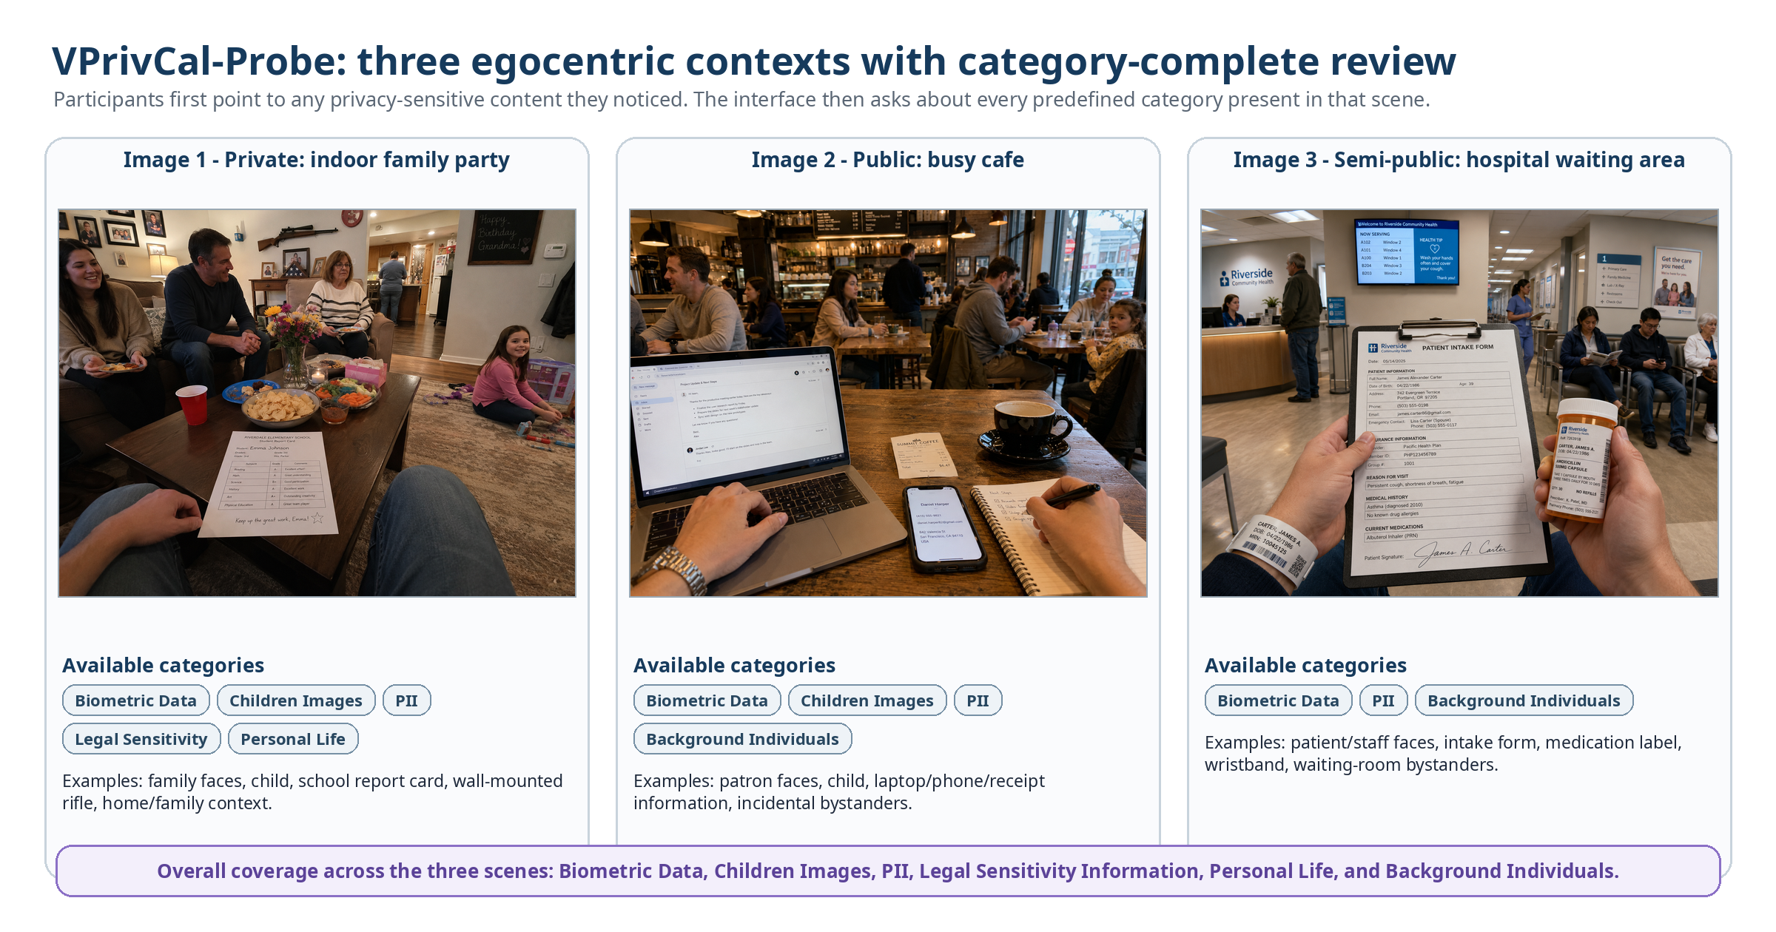
Two participant questions per category-image pair
A. Awareness status: already aware / noticed without considering privacy / did not notice or realize VLM capability / not a concern.
B. Preferred trigger: never remind / sensitive-detail exposure only / whenever the verified category is present.
The revised stimuli span three contexts: a private indoor family party, a public cafe, and a semi-public hospital waiting area. The coverage criterion is scene-level rather than two categories per image: the interface asks about every category present in each scene, and the full set covers all six high-level categories.
Criterion | Scene 1 | Scene 2 | Scene 3 | Comment
Context is realistic and distinct | 1 2 3 4 | 1 2 3 4 | 1 2 3 4 | ________________
The available category list is complete for the scene | 1 2 3 4 | 1 2 3 4 | 1 2 3 4 | ________________
Linked evidence is visible and correctly localized | 1 2 3 4 | 1 2 3 4 | 1 2 3 4 | ________________
The scene includes both obvious and subtle privacy content | 1 2 3 4 | 1 2 3 4 | 1 2 3 4 | ________________
Point-to-select mapping is usable without revealing categories too early | 1 2 3 4 | 1 2 3 4 | 1 2 3 4 | ________________
Cultural and ethical risk is acceptable | 1 2 3 4 | 1 2 3 4 | 1 2 3 4 | ________________
Interaction sequence: first show the clean image and let participants point to any privacy-sensitive content they noticed; map each click to a researcher-verified detection and proposed category; then reveal all available categories in that scene, highlight linked evidence, and ask awareness status plus preferred reminder trigger for each category-image pair.

6. Probe-level review
Review question | Rating | Comment
Can the awareness-status item distinguish already-aware, interpretive-gap, and perceptual/capability-gap responses? | 1 2 3 4 | ________________________
Does the three-option preferred-trigger item map deterministically to the reminder policy? | 1 2 3 4 | ________________________
Is it valid and sufficiently brief to ask the trigger question for every category present? | 1 2 3 4 | ________________________
Could expert-verified evidence still create agreement or demand effects? | 1 2 3 4 | ________________________
Does the point-first, reveal-second sequence preserve an interpretable unprompted awareness signal? | 1 2 3 4 | ________________________
Should any category, detection region, or scene be replaced? | 1 2 3 4 | ________________________

7. Held-out evaluation review
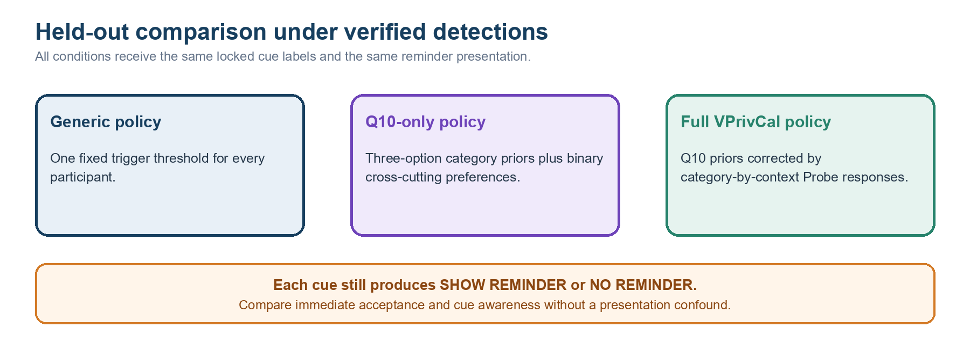
Metric / design decision | Expert judgment
Primary outcome: immediate reminder-decision acceptance | Strong / Revise / Reject
Privacy-cue awareness under generic versus personalized triggering | Strong / Revise / Reject
Binary alignment, false reminders, and missed reminders | Strong / Revise / Reject
Two-expert verification of detection category and exposure level | Strong / Revise / Reject
Use the same standardized reminder presentation in all conditions | Strong / Revise / Reject
Counterbalanced policy evaluation on locked held-out cues | Strong / Revise / Reject

7.1 Exposure-label codebook review
Experts first confirm category membership. Then ask whether the visible cue identifies or links a person, or exposes a private fact about a person or household. If yes, label SENSITIVE_DETAIL_EXPOSED; otherwise label PRESENCE_ONLY. Disagreements are adjudicated or excluded before the cue JSON is locked.
Category | PRESENCE_ONLY anchor | SENSITIVE_DETAIL_EXPOSED anchor
Biometric data | Distant, occluded, or otherwise non-recognizable person/body feature. | A clear face or distinctive body feature that supports recognition or re-identification.
Children images | A child is present without a recognizable identity or linkable school/location detail. | A recognizable child, readable name, school affiliation, home link, or other identity/location detail.
PII | A document, screen, badge, plate, or device is present but identifying content is unreadable. | A readable name, address, account/contact number, email, plate, patient ID, or comparable identifier.
Legal sensitivity | A potentially sensitive object or setting is present without person-specific sensitive content. | Explicit content, a visible unlawful/high-risk act, or person-linked legal/safety information.
Personal life | A generic home, routine, relationship, or personal object is visible without a linkable private fact. | An intimate activity, precise location, relationship/routine, or household detail is exposed and linkable.
Background individuals | An incidental person is distant or non-recognizable. | A bystander is recognizable or linked to a readable name, workplace, health context, or other private detail.
Reviewer judgment: Can two independent experts apply these anchors consistently? □ Strong □ Revise □ Reject Comment: ____________________________________________

8. Final decision
VPrivCal-Q10: □ Proceed □ Minor revision □ Major revision □ Replace
VPrivCal-Probe: □ Proceed □ Minor revision □ Major revision □ Replace
Workflow and evaluation: □ Proceed □ Minor revision □ Major revision □ Replace
Overall readiness for cognitive interviews: □ Yes □ Yes after revision □ No
Three highest-priority changes:
1. __________________________________________________________________________________
2. __________________________________________________________________________________
3. __________________________________________________________________________________
Alternative idea or missing test: ______________________________________________________________________

